Release notes WDCAP version 3.0.4 (11-5-2019)

At 11-5-2019 a new WDCAP version will be installed with the following changes:

Advanced Search / New option to search on age

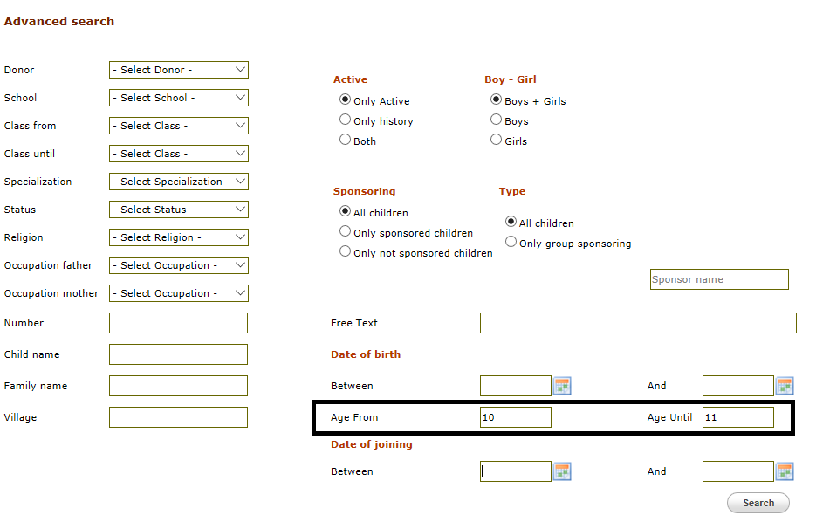

On the advanced search screen (see above) a new option is added to extend the search criteria with the age of the children. On the search result screen the age is added (see below)

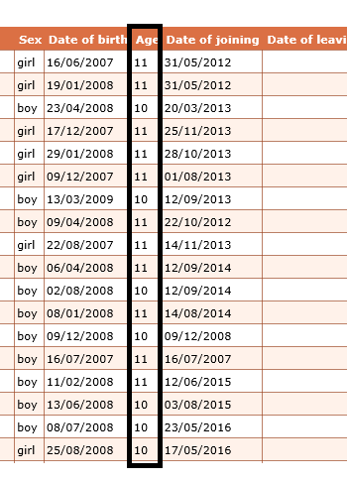

New / existing child / Living situation changed in 4 questions

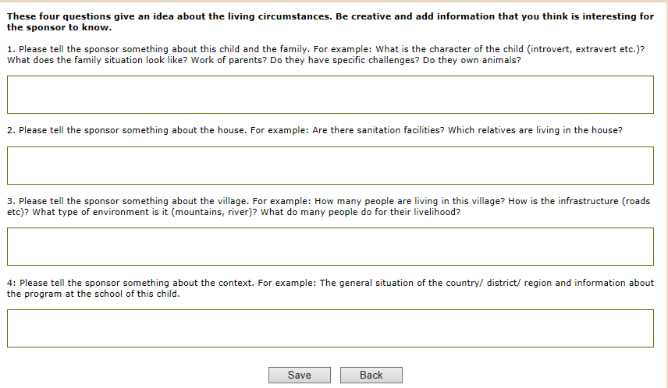

In order to improve the quality of information that we send to the sponsors about the living situations of the children, we have designed 4 relevant questions. See screen-print above. In total these questions give a good picture of the living situation, so please fill them all with information.
The answer of the 4 questions will be combined to 1 description. The sponsors won’t see the 4 different questions. So please make sure you don’t answer the questions with only a ‘yes’, but shortly repeat what the question is about
For example:
Question 2: ‘Please tell the sponsor something about the house: for example: is there sanitation facilities? Which relatives are living in the house?
Please DO answer like: In the house of the family a bathroom with a toilet is available. The child lives with his parents, 3 brothers and 2 sisters. (…)
Please DON’T answer like: ‘yes there is sanitation available’

New / existing child / Quality check

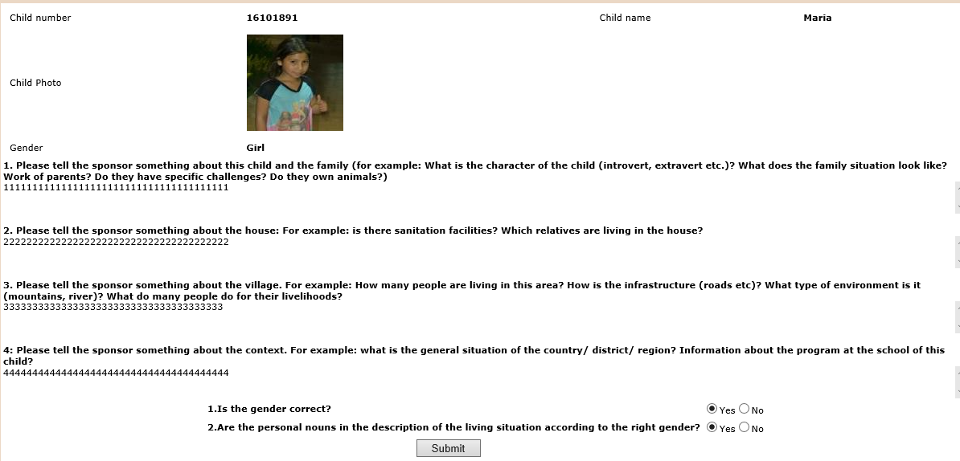

If a new child is entered or an existing child is modified the screen above is activated where you can check if the relevant child details (boy/girl / living situation / photo etc.) are correct.

Family details / new option “Passed away”

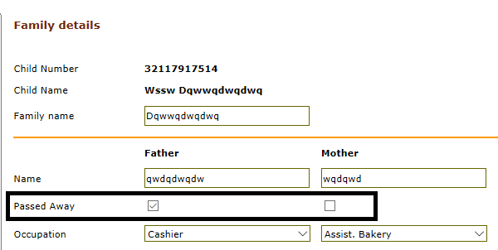

A new field “Passed away” is added to indicate whether the father and/or mother of the child passed away. (This is used in the new biodata form to define whether the child is orphan or from 1 parent )

Child details / Translation options for (transfer) forms’

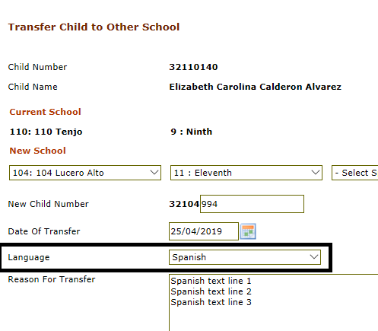

There is a new option to specify that the entered text is in another language than the language of the donor. In this case it is not possible to send the leaving if the translation is not entered.
When the translation is entered the transfer form can be sent to the donor (with the translated text). See screen-prints below.

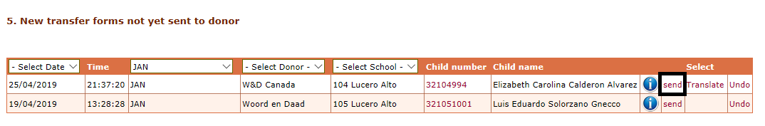

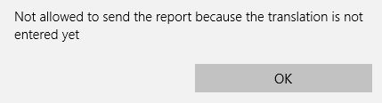

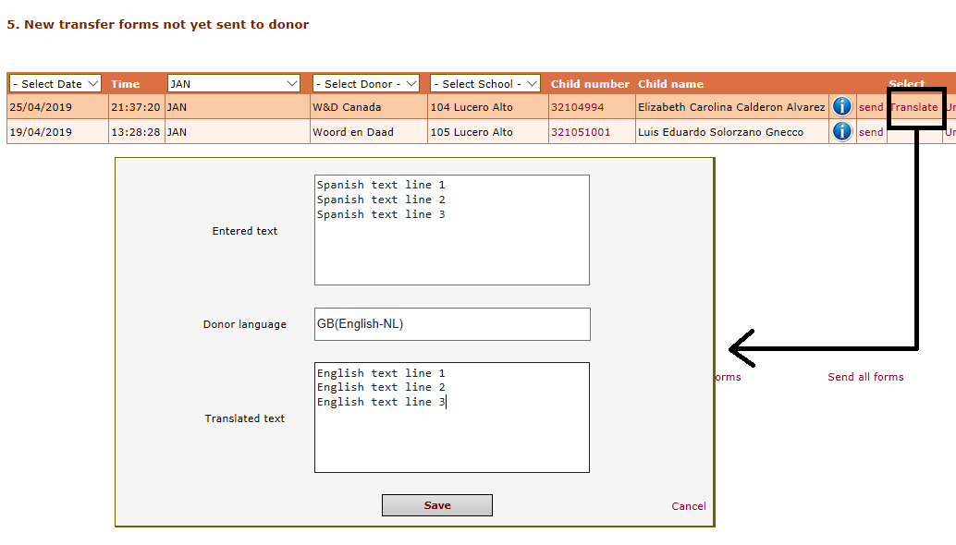

Child details / Child leaving

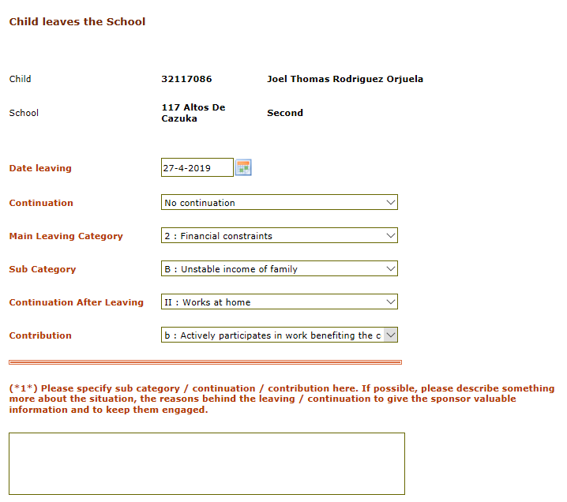

There is a new screen to enter the leaving details when a child leaves the school.
This screen combines the leaving for education and sponsoring.
See above an example. The content of the selection lists depends on earlier choices.
See below an example of the new leaving form.

More detailed instructions regarding administration and PMEL will be sent soon.

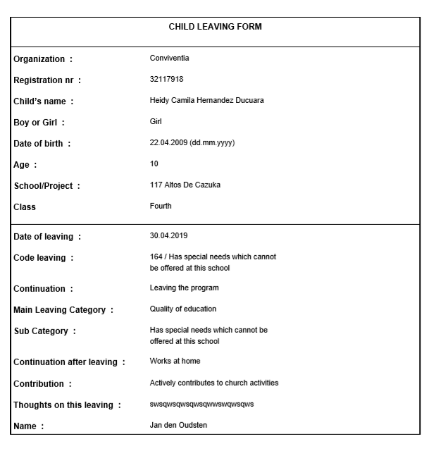

Child details / Progress report

There is a new progress report (2019 style available)

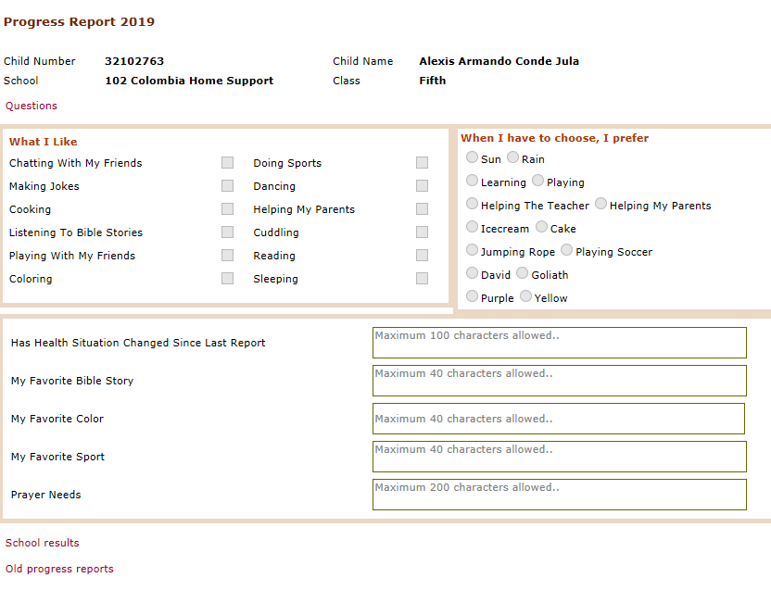

There is also a version available for the Kobo Toolbox.
You can start this via the link below
https://ee.kobotoolbox.org/x/#MfWeB5i4

Child details / Greetings history / Thankyou letter sent

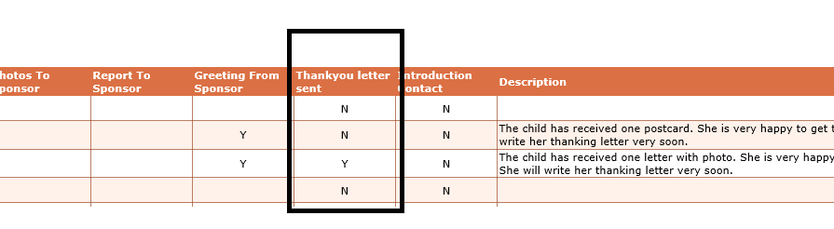

New column added “Thankyou letter sent” (as response to a greeting from the sponsor) and also the user who entered the greeting.

Actions / Greetings to sponsors / Donor and status displayed

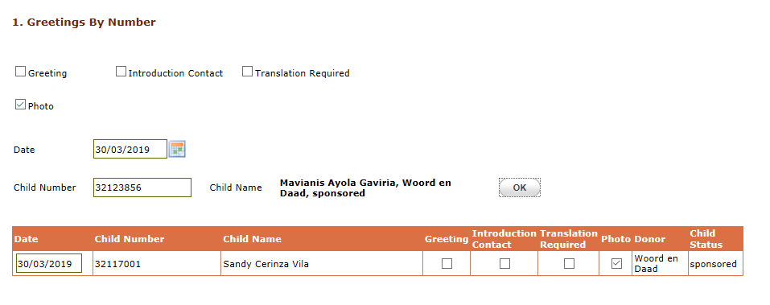

If you enter a child number then the program will not only display the name of the child but also the name of the donor and the status of the child

Actions / New schoolyear

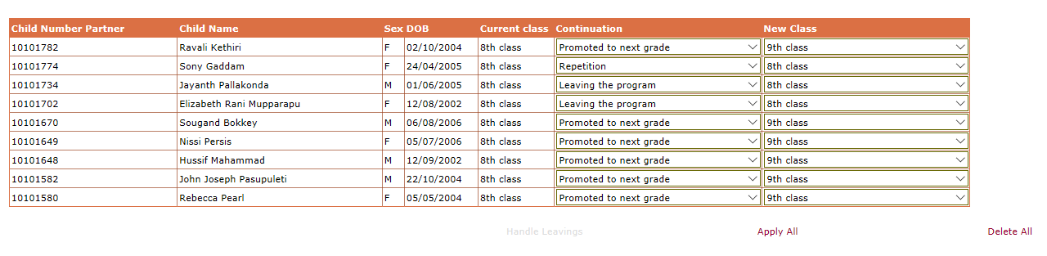

This screen is very simplified. Only Continuation and New class can be modified.
After selecting the correct code and class you can press Apply All.
Now all children where the continuation code is “Promoted to next grade”, “Repetition” and “Continue further education” are modified and removed from the list.(see below)
Via link “Handle leavings” the remaining children can be handled.

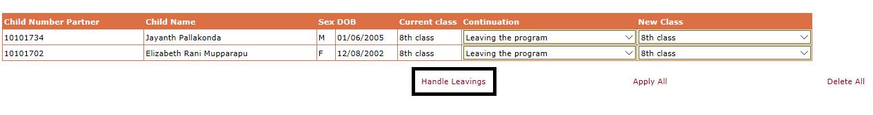

This works the same as if the leaving is handled via the link Child Leaving on the child details screen (see below) .

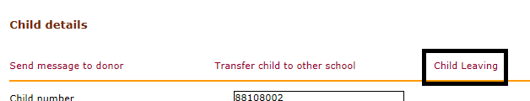

Actions / Greetings from sponsors / Donor and status displayed

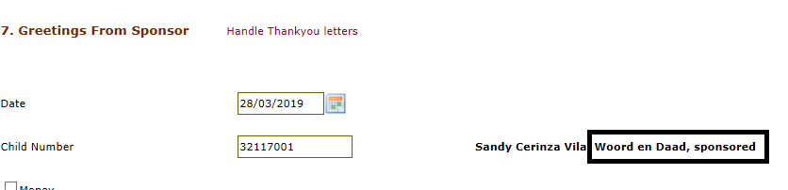

If you enter a child number then the program will not only display the name of the child but also the name of the donor and the status of the child

Actions / Message for Sponsoring Office (new)

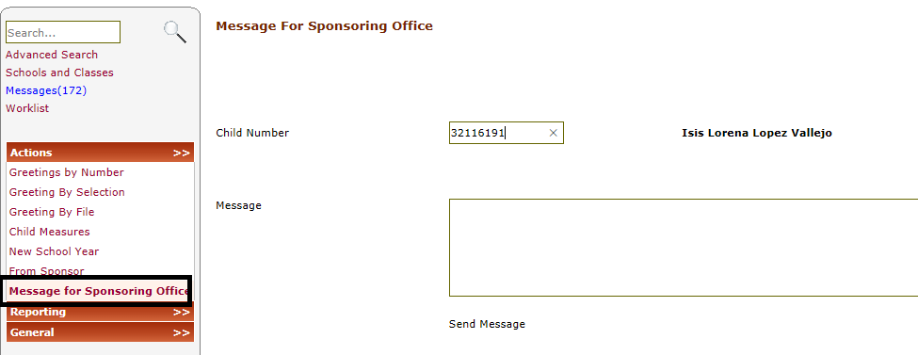

With this new option it is possible that people outside the sponsoring office (f.i. teachers and social workers) can send information about the child to the sponsoring office. (see screen-print above)
These messages are added to a new worklist 26 (see below) that can be handled by the sponsoring office.

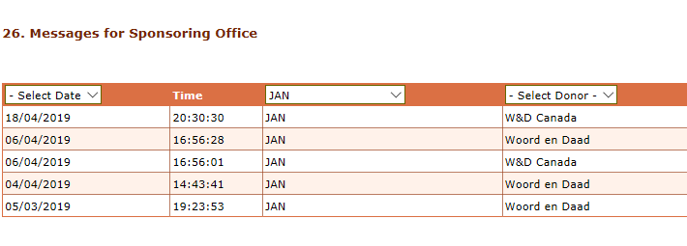
At the end of the line in the worklist is a link to handle the message.
This message can be forwarded to the donor. If you click handle the handled line in the worklist is deleted. In both cases the message is added to the child history.
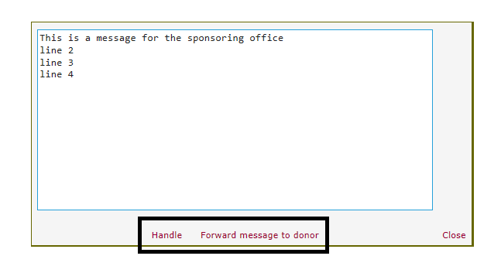

Reporting / Selections

There are 2 new columns added to the excel file (Group Sponsoring and Donor)

Reporting / Greetings from sponsors

The donor name is added to the excel file with greetings from sponsors
This excel file is also extended with the date and the user who entered the thankyou letter for the greeting from the sponsor (which gives you also an overview of the greetings from the sponsor where no thankyou letter is sent)

Reporting / Greetings to sponsor (new)

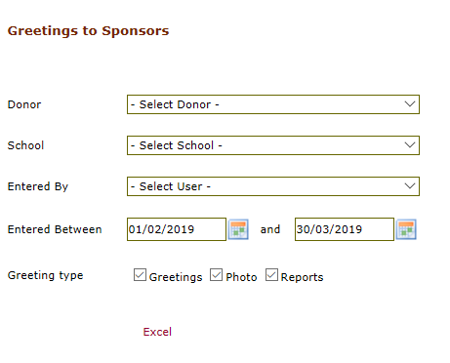

New option to create an excel file with all greetings, photos and progress reports that were sent to the sponsors.
See above the selection criteria.
See example below.

Reporting / Education statistics

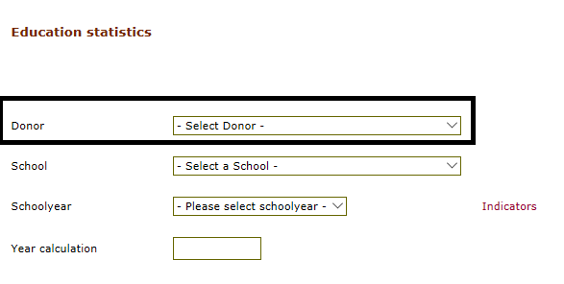

New filter added to create the education statistics for the children of 1 donor instead of all children.

Reporting / Sponsorship statistics (new)

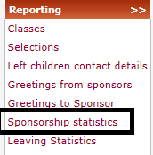

If this option is selected the program automatically creates an Excel file with an overview of the total number of children per school / Donor / Sponsored / Type of education /Male or female.
See below an example of the total lines.

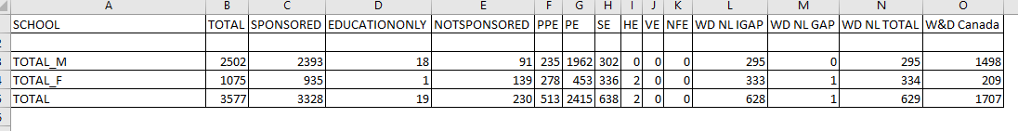

Reporting / Leaving statistics

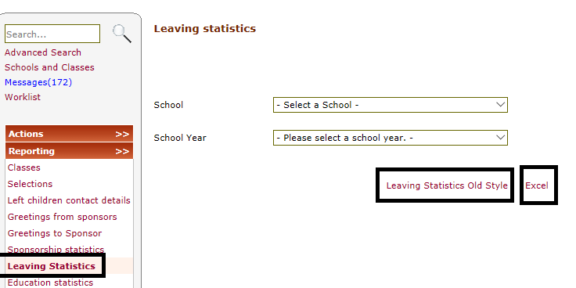

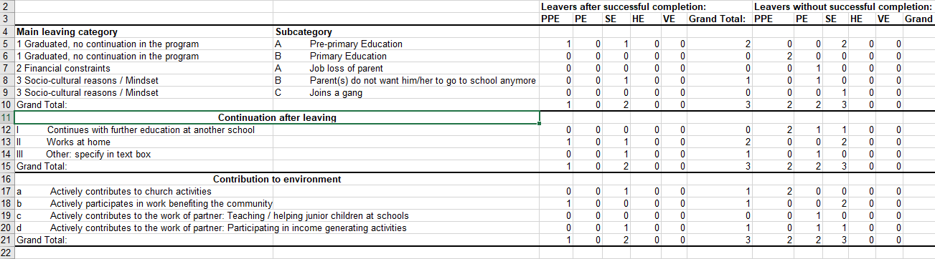

The leaving statistics are adjusted and contain a summary of the leavings that are entered via the new screens. It is possible to select 1 school and if no school is selected the statistics are for all schools. It is mandatory to select a schoolyear. Via the Excel link Excel is started with the leavings statistics new style (see screen-print with example).

There is also a link “Leaving statistics Old Style” available. Via this link the Leaving statistics are created as in the past.

Reporting / Daily activity log (new)

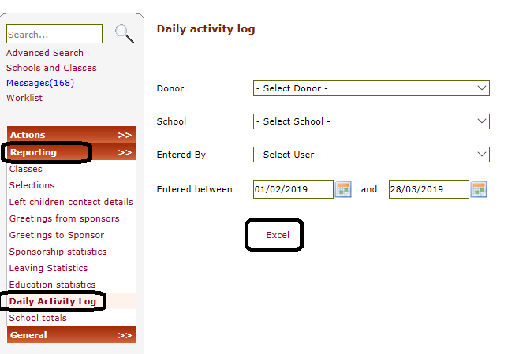

With this new reporting program it is possible to get a list of all changes in WDCAP with filters on donor, school, user and period.

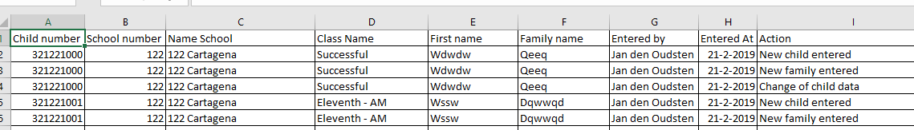

Sending documents to other donors

With this release it is possible to configure the donor details that the documents that are currently sent electronically to Woord en Daad will be sent via email to other donors.
This is available for the following
Worklist 1 – Biodata forms
Worklist 5 – Transfers
Worklist 6 – Leavings
Worklist 10 – Progress reports
Messages.
If you want to activate this feature then please contact Jan den Oudsten (oudsten@wxs.nl)

